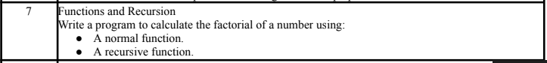
COMMAND:
'''Functions and Recursion
Write a program to calculate the factorial of a number using:
● A normal function.
● A recursive function'''

# Factorial using normal (iterative) function
def factorial_iterative(n):
result = 1
for i in range(1, n + 1):
result *= i
return result

# Factorial using recursive function
def factorial_recursive(n):
if n == 0 or n == 1: # Base case
return 1
return n * factorial_recursive(n - 1) # Recursive call

# Taking user input
num = int(input("Enter a number: "))

# Display results
print("Factorial (Iterative):", factorial_iterative(num))
print("Factorial (Recursive):", factorial_recursive(num))

OUTPUT:
